**HOW TO BLINK THE BUILT-IN LED’S USING NODE MCU-ESP8266**

We all familiar with blinking LED using Arduino boards as this is the fundamental step towards using a new development board.

Here we are using node MCU-ESP8266.

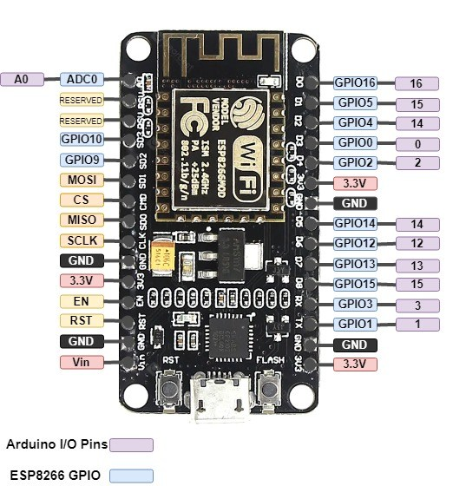

This is how a ESP8266 looks like.

To blink the built-in LEDs we have to only connect Node MCU to the computer using a micro USB cable. No external component is required.  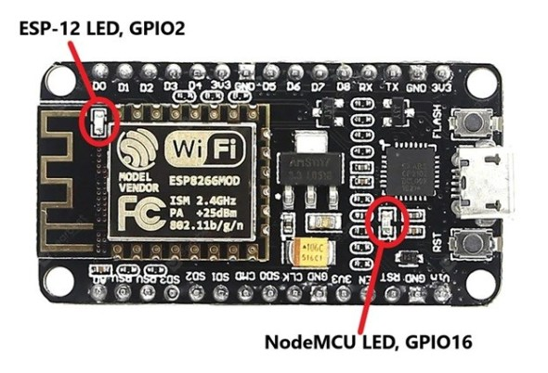

* On Board LED for ESP8266 is connected wtih GPIO2.
* For NodeMCU it is connected with GPIO16

### **Code for Built-in LED Blinking**

This code is to blink built-in LEDs of NodeMCU. The on-board LED of ESP8266 is connected to GPIO2 and ths LED on NodeMCU board is connected to GPIO16.  Working of this code is same as we explained earlier for external **LED blinking** with NodeMCU.

int LED1 = 2;      // Assign LED1 to pin GPIO2

int LED2 = 16;     // Assign LED1 to pin GPIO16

void setup() {

// initialize GPIO2 and GPIO16 as an output

pinMode(LED1, OUTPUT);

pinMode(LED2, OUTPUT);

}// the loop function runs forever

void loop() {

digitalWrite(LED1, LOW);     // turn the LED off

  digitalWrite(LED2, HIGH);

  delay(1000);                // wait for a second

  digitalWrite(LED1, HIGH);  // turn the LED on

digitalWrite(LED2, LOW);

  delay(1000);               // wait for a second

}

REGARDS:

NARSIMHA REDDY

DHEERAJ T

RAGASRI YARLAGADDA